A

PROJECT REPORT

ON

“MEAL CONNECT”

SUBMITTED TO

SHIVAJI UNIVERSITY, KOLHAPUR

IN THE PARTIAL FULFILLMENT OF THE REQUIREMENT
FOR THE AWARD OF DEGREE
BACHELOR OF TECHNOLOGY IN COMPUTER SCIENCE AND ENGINEERING

SUBMITTED BY

MR. | SUHAS SAMBHAJI MASALE | PRN : 22UAD041
MR. | PRANAV BALASAHEB PATIL | PRN : 22UAD049

UNDER THE GUIDANCE OF

Mr. S. P. Pise



DEPARTMENT OF ARTIFICIAL INTELLIGENCE AND DATA SCIENCE ENGINEERING
DKTE SOCIETY’S TEXTILE AND ENGINEERING INSTITUTE, ICHALKARANJI
(AN EMPOWERED AUTONOUMOUS INSTITUTE)
2024-2025

D.K.T.E. SOCIETY’S

TEXTILE AND ENGINEERING INSTITUTE, ICHALKARANJI
(AN EMPOWERED AUTONOUMOUS INSTITUTE)

DEPARTMENT OF ARTIFICIAL INTELLIGENCE AND DATA SCIENCE ENGINEERING



CERTIFICATE

This is to certify that, project work entitled

“MEAL CONNECT”

is a bonafide record of project work carried out in this college by

MR. | SUHAS SAMBHAJI MASALE | PRN : 22UAD041
MR. | PRANAV BALASAHEB PATIL | PRN : 22UAD049

is in the partial fulfillment of award of degree Bachelor of Technology in Artificial Intelligence and Data Science Engineering prescribed by Shivaji University, Kolhapur for the academic year 2024-2025.

MR. S. P. PISE
(PROJECT GUIDE)

PROF. (DR.) T. I. BAGBAN PROF.(DR.) L.S.ADMUTHE
(HOD AI & DS DEPT.) (DIRECTOR)

EXAMINER: ________________
DECLARATION

We hereby declare that, the project work report entitled “Meal Connect” which is being submitted to D.K.T.E. Society’s Textile and Engineering Institute Ichalkaranji, affiliated to Shivaji University, Kolhapur is in partial fulfillment of degree B.Tech.(AI & DS). It is a bonafide report of the work carried out by us. The material contained in this report has not been submitted to any university or institution for the award of any degree. Further, we declare that we have not violated any of the provisions under Copyright and Piracy / Cyber / IPR Act amended from time to time.

Title | Name of the Student | PRN | Signature
MR. | SUHAS SAMBHAJI MASALE | 22UAD041
MR. | PRANAV BALASAHEB PATIL | 22UAD049

ACKNOWLEDGEMENT

With great pleasure we wish to express our deep sense of gratitude to Mr. S. P. Pise for his valuable guidance, support, and encouragement in the completion of this project report.
Also, we would like to take the opportunity to thank our head of department Dr. T. I. Bagban for his cooperation in preparing this project report.
We feel gratified to record our cordial thanks to other staff members of the Artificial Intelligence and Data Science Department for their support, help, and assistance which they extended as and when required.

Thank you,
Title | Name of the Student | PRN
MR. | SUHAS SAMBHAJI MASALE | 22UAD041
MR. | PRANAV BALASAHEB PATIL | 22UAD049

ABSTRACT
MealConnect is a digital platform that addresses food wastage and hunger in India by connecting surplus food donors—like restaurants and households—with nearby NGOs. Using a location-based matching algorithm, it ensures timely redistribution to reduce spoilage. Donors can easily list excess food through a user-friendly interface, and NGOs can claim the food based on proximity and requirement. The platform supports volunteer coordination and provides live status updates to ensure transparency. An analytics dashboard tracks the impact, including food saved and meals served. Built with React.js, Node.js, and MongoDB, MealConnect promotes sustainability through community-driven food sharing.

INDEX

- Introduction << >>

  - Problem definition << >>

  - Aim and objective of the project << >>

  - Scope and limitation of the project << >>

- Background study and literature overview << >>

  - Literature overview << >>

  - Investigation of current project and related work << >>
- Requirement analysis << >>
a. Requirement Gathering << >>
b. Requirement Specification << >>
c. Use case Diagram << >>
- System design << >>

  - Architectural Design << >>

  - Flow Chart << >>

  - System Modeling << >>

    - Dataflow Diagram << >>
- Implementation << >>

a. Agile Methodologies << >>
b. Development Model << >>
- Future Scope << >>

- References (Public repository GitHub source code links) << >>

1. Introduction

a. Problem Definition
Every year, a large amount of food is wasted globally, with India alone accounting for millions of tons. At the same time, a significant portion of the population continues to suffer from hunger and malnutrition. Despite the efforts of NGOs and food donors, the lack of a real-time and structured platform prevents efficient redistribution of surplus food. The absence of digital connectivity between donors and NGOs leads to delays, food spoilage, and missed opportunities to serve those in need.

b. Aim and Objective of the Project
The primary aim of this project is to develop MealConnect, a smart and efficient digital platform that bridges the gap between food donors and NGOs. The objectives include:
- Creating a real-time food donation and claiming system.
- Implementing a location-based matching algorithm to ensure fast allocation.
- Enabling status tracking for volunteers to ensure transparency in collection and delivery.
- Generating analytical insights on the impact through a centralized dashboard.

c. Scope and Limitation of the Project

Scope:
- Real-time connectivity between food donors and NGOs using a web-based interface.
- Efficient food redistribution with the help of smart algorithms.
- Monitoring and analysis of impact through dashboards.
- Volunteer involvement for pickup and delivery logistics.

Limitations:
- Dependence on internet connectivity and digital literacy among users.
- Food safety and hygiene compliance as per FSSAI regulations.
- Volunteer availability may affect timely pickups in certain areas.
- Limited to regions and cities where NGOs and donors are actively registered on the platform.

2. Background study and literature overview

a. Literature Overview
Food wastage is a globally recognized issue, with the United Nations Food and Agriculture Organization (FAO) estimating that nearly one-third of all food produced globally is wasted. In India, according to multiple studies and reports, more than 68 million tons of food are wasted annually. This food, if effectively redistributed, could feed millions of undernourished people.
Several research papers and articles highlight the lack of coordination between food donors and NGOs as one of the primary reasons for this waste. There is also a need for better logistics, real-time tracking, and digital solutions to facilitate food recovery and donation processes. While platforms like Feeding India and No Food Waste have made strides, they often rely on manual coordination or lack comprehensive real-time matching systems.
Additionally, the FSSAI (Food Safety and Standards Authority of India) has introduced guidelines for food donations, which stress the importance of handling and redistributing food in a hygienic and safe manner. However, there is still a gap in technology adoption among grassroots-level donors and NGOs.

b. Investigation of Current Projects and Related Work
Several existing initiatives attempt to address food wastage, but most have limited scalability, regional restrictions, or lack real-time features. Some notable efforts include:
- Feeding India (Zomato): Focuses on food collection and redistribution but relies heavily on manual volunteer coordination.
- No Food Waste: Uses an app to collect and distribute food in specific cities but lacks advanced automation and analytics.
- Robin Hood Army: Works through volunteers to collect excess food, but coordination is often done via social media and messaging apps.
Despite these efforts, no unified, exists that connects all stakeholders—donors, NGOs, and volunteers—with features like location-based matching and impact dashboards.
MealConnect aims to fill this gap by offering a comprehensive and scalable platform using modern web technologies to ensure efficient and transparent food redistribution.

3. Requirement analysis

a. Requirement Gathering
To build an effective platform for real-time food redistribution, the following requirements were identified through user interaction, research on similar platforms, and analysis of the problem domain:
Stakeholders:
- Food Donors (restaurants, households, event organizers)
- NGOs (non-profit organizations)
- Volunteers (delivery/collection personnel)
- Admin (platform management)
Functional Requirements:
- Donors should be able to post surplus food with quantity, location, and expiry time.
- NGOs should get alerts of nearby available food items.
- Volunteers should be able to register and view assigned pickups.
- Admin should monitor the overall operations and impact analytics.
- Users should receive real-time updates on donation and pickup status.
Non-Functional Requirements:
- System should be responsive and mobile-friendly.
- Real-time data syncing with minimal latency.
- Secure login and access control for different user types.
- Data should be stored efficiently with backup support.
- Ensure compliance with FSSAI food donation norms.

b. Requirement Specification
Module | Functionality
Food Donor | Register, login, post food details, view history
NGO | Register, login, view available food, claim food, track delivery
Admin | View statistics, manage users, monitor platform activities
Dashboard | Display food saved, meals served, volunteer activity, and other analytics

c. Use Case Diagram
Here's a simple Use Case Diagram representing the interactions among major components of MealConnect:

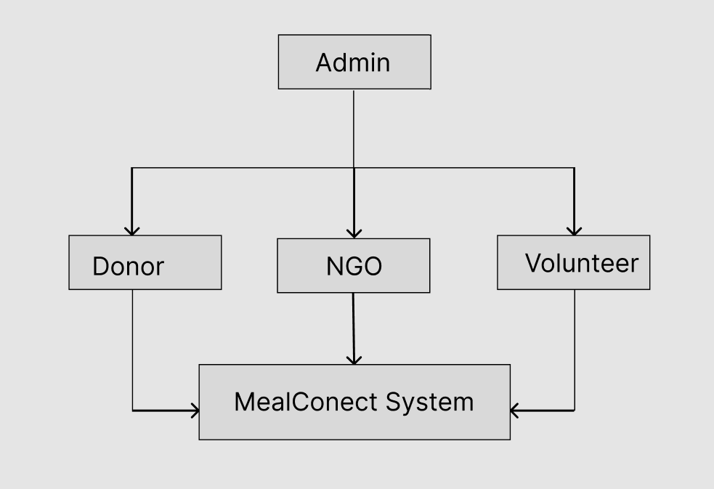

4. System design

a. Architectural Design:
MealConnect follows a client-server architecture where:
- Frontend: The user interface is built using React.js with CSS for styling. This allows a smooth, responsive interface where donors can easily post food details, and NGOs can claim the donations.
- Backend: The backend is built with Node.js and Express.js, handling API requests for food postings, real-time updates, and matching logic.
- Database: MongoDB stores data on food donations, donors, NGOs, and volunteers. This NoSQL database is chosen due to its flexibility in handling various data types (e.g., food details, NGO info).
- Authentication: JWT-based authentication ensures that both food donors and NGOs can securely log in, view their data, and post or claim food donations.

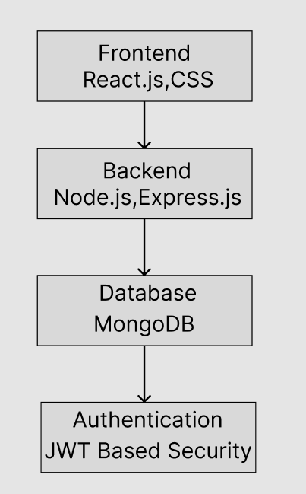

b. Flow Chart:
- Food Donor posts surplus food:
  - Donor logs in and enters food details (type, quantity, expiry, etc.).
  - The system stores the donation in the database and updates the matching algorithm.
- NGOs receive notifications:
  - NGOs near the donor’s location receive an alert about the food donation.
  - The NGO can review the details and claim the food donation.
- Matching Algorithm:
  - The algorithm calculates proximity and matches donors with the nearest and most in-need NGO.
  - An automated system assigns the donation based on these parameters.
- Collection and Status Update:
  - Volunteers collect the food from the donor and update the status of the donation (e.g., collected, delivered).
- Analytics Dashboard:
  - The system tracks food donations, meals provided, and donor/NGO activity.
  - Insights on donation frequency, areas with the most food waste, and impact statistics are displayed on the dashboard.

c. System Modeling:

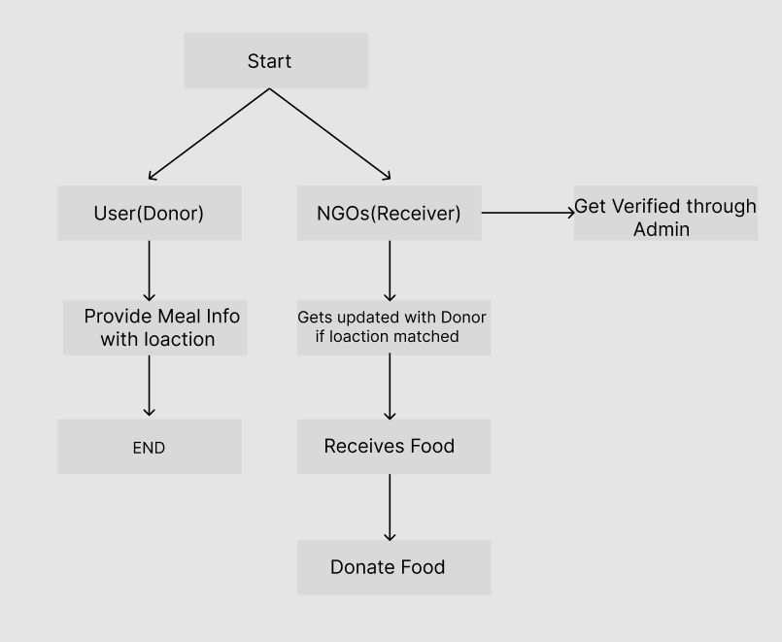
1. Dataflow Diagram:

Description of the Flow:
- Donor → Backend
Donor submits meal availability and quantity via app/web.
- Backend (System)
  - Validates input
  - Stores in the database
  - Updates real-time availability for NGOs
  - Sends confirmation to donor and notifies NGOs
- Admin → Backend
Admin logs in to manage donor/NGO data, system reports, and operational flow.
- NGO → Backend
NGOs log in to check meal listings, request pickups, and update status once meals are collected.

5. Implementation

a. Agile Methodologies:
Agile methodologies will be used throughout the development of the MealConnect platform to ensure flexibility, quick iteration, and continuous improvement. The key principles of Agile will guide the project, including:
- Iterative Development:
The platform will be developed in small, manageable increments, with each sprint focusing on delivering a specific set of features. This allows for frequent releases and early user feedback.
- Collaboration with Stakeholders:
Regular meetings with stakeholders (food donors, NGOs, volunteers) will ensure their needs and feedback are incorporated into the development process. This helps prioritize features that will have the most impact.
- Responsive to Change:
Agile enables the project team to respond to changes in requirements or new insights gained from user feedback during the development process. This is crucial in building a product that evolves with the needs of its users.
- Focus on Quality:
Continuous testing, code reviews, and quality assurance during each sprint will ensure that the platform remains bug-free and functions as intended.
- Scrum Framework:
We will adopt Scrum as the Agile framework, with defined roles such as Product Owner, Scrum Master, and Development Team. The Scrum team will conduct daily standups, sprint planning, sprint reviews, and retrospectives to keep the development on track.

b. Development Model:
To ensure the successful creation and deployment of MealConnect, a structured development model will be followed, consisting of the following phases:
- Requirement Gathering and Planning:
  - User Stories: Gather user stories from food donors, NGOs, and volunteers to understand their needs.
  - Feature Prioritization: Based on these stories, prioritize features like real-time donation posting, location-based matching, and chatbot assistance.
  - Timeline and Milestones: Define the overall timeline for each sprint, keeping milestones in place for version releases.
- System Design:
  - Architecture Design: Define the high-level architecture of the platform, ensuring it supports scalability and performance. MongoDB will be used for data storage, with the frontend (React.js) and backend (Node.js with Express.js) providing a robust structure.
  - UI/UX Design: Focus on an intuitive, user-friendly interface using Tailwind CSS. Wireframes and mockups will be created and refined through feedback.
- Development and Testing (Sprint-Based):
  - Sprint 1: Develop core features like food donation posting and location-based notifications for NGOs.
  - Sprint 2: Implement the matching algorithm
  - Sprint 4: Final testing, bug fixes, and deployment of the beta version.
Each sprint will have associated tasks, such as backend development, frontend UI enhancements, database schema implementation,
Deployment and Release:
  - Continuous Integration/Continuous Deployment (CI/CD): Automate testing and deployment processes using tools like GitHub Actions to streamline the release of new features.
  - Staging Environment: Deploy new features first to the staging environment for testing before moving to production.
  - Monitoring and Performance Tuning: Use tools like Google Analytics or custom logs to monitor user activity and server performance post-launch.
- Post-Launch Support and Updates:
  - User Feedback: After the initial launch, gather feedback from donors, NGOs, and volunteers to refine features and fix any issues.
  - New Features: Based on user needs, release updates and new features (e.g., mobile app support, more advanced analytics).

6. Future Scope

The MealConnect platform has significant potential for growth and improvement in the future. Here are some possible directions for expansion and enhancement:

a. Mobile Application:
- Native Mobile Apps: Developing Android and iOS applications would increase accessibility, making it easier for food donors and NGOs to interact with the platform on the go.
- Push Notifications: Mobile apps can support real-time push notifications, alerting users about new food donations or updates to their claims.

b. Global Expansion:
- International Reach: Currently focused on local or regional operations, MealConnect can expand globally, adapting to the food donation regulations and challenges of other countries.
- Multi-language Support: To cater to diverse regions, the platform can introduce multiple language options to help users from different backgrounds access the platform effectively.

c. AI and Machine Learning Advancements:
- Predictive Analytics: Implementing machine learning algorithms to predict food surplus trends and optimize donation needs based on seasonality and local food consumption patterns.
- Smart Matching Algorithm: Using AI to improve the matching process by considering food types, expiration dates, nutritional needs, and dietary restrictions of recipient communities.
- Food Quality Assessment: AI could help assess the quality of donated food by analyzing images or detecting expiry dates to ensure safety and freshness.

7. References (public repository GitHub source code links)

Food wastage by country - https://worldpopulationreview.com/country-rankings/food-waste-by-country

FSSAI regulations for food distribution - https://ssrana.in/articles/fssai-food-donation-regulations/

GITHUB –
https://github.com/aayush301/Food-donation-management-system

